**FPT ACADEMY INTERNATIONAL**



## FPT – APTECH COMPUTER EDUCATION

**HANDICRAFTS**

|  |  |  |  |  |  |  |
| --- | --- | --- | --- | --- | --- | --- |
| **Center Name** | | | FPT – Aptech – HCM  Address: 590 Cach Mang Thang Tam, District 3, Ho Chi Minh City | | | |
| **Instructor** |  | | Mr. Le Thanh Nhan | |  | |
| **Class** |  | | T1.2203.E1 | |  | |
| **Group** |  | | 05 | |  | |
| **Group members** | | | **Name** | | **Student ID** | |
|  |  | | Pham Thien Phuc | | Student1370226 | |
|  |  | | Luu Vinh Han | | Student1368161 | |
|  |  | | Pham Van Man | | Student1370227 | |
|  |  | | Tran Quoc Tien | | Student1373324 | |
| **Duration** | Start date | | 11th June 2022 |  | |
| End date | | 19th July 2022 |  | |
|  | |
|  | |

**This is to certify that**

**Mr.:**

Pham Thien Phuc

Luu Vinh Han

Pham Quoc Man

Tran Quoc Tien

**has successfully designed & developed**

eProject: Handicrafts

**Submitted by:**

Pham Thien Phuc

**Date of issue:**

**Authorized Signature:**



**TABLE OF CONTENTS**

FPT – APTECH COMPUTER EDUCATION 1

ACKNOWLEGMENT 4

SYNOSIS 5

PROBLEM STATEMENT 6

CUSTOMER'S REQUIREMENTS SPECIFICATIONS (CRS) 7

Business/Project Objective: 7

Input to the system: 7

Process: 7

Output from the system: 8

Expected delivery date: 8

List of deliverables: 8

Hardware/ Software Requirements: 8

SCOPE OF THE WORK (IN BRIEF) 9

ARCHITECTURE AND DESIGN OF THE SYSTEM 10

Diagram of the website 11

TASK SHEET REVIEW 1 12

SITE MAP 13

MOCK OF THE WEBSITE 14

**1.** **Homepage** 14

**2.** **Products** 15

**3.** **About us** 16

**4.** **Gallery** 17

**5.** **Contact** 18

**6.** **FAQS** 19

**7.** **Site map** 20

TASK SHEET REVIEW 2 21

WEBSITE DESCRIPTION 22

**1.** **Home Page** 22

**2.** **Product** 24

**3.** **Gallery** 27

**4.** **About us** 28

**6.** **FAQS** 32

**7.** **Site map** 34

WEBSITE REPONSIVE 35

35

35

TASK SHEET REVIEW 3 39

# ACKNOWLEGMENT

First and foremost, I would like to thank the eProject. As we learned Logic Building and Elementary, HTM5, CSS, Javascript, Angular JS from subjects. Those are separate subjects and we have not had the experience to combine the knowledge of these subjects to put them into the real-life world. But this project has been a source to learn and bring our theoretical knowledge to complete a real project. The values that the project brings are as follows:

* Practice step by step i.e. laddered approach.
* Build a larger more robust application.
* Usage of certain utilities in applications designed by user.
* Single program to unified code leading to a complete application.
* Learn implementation of concepts in a phased manner.
* Enhance skills and add value.
* Work on real life projects.
* Give a real life scenario and help to create applications more complicated and useful.

Thereby, it helps us to have new knowledge, new experiences, experience so that we are ready for future real projects. So, I would really acknowledge infomation and the “demo” project from India APTECH.

Secondly, I sincerely thank to Mr. Le Thanh Nhan, my supervisor who gave me useful guidance and advice that help we to finish my eProject successfully. He made us understand how to successfully complete this project and without him, the project would not have been complete.

Also, we would like to send a great thank to our professor and others student, who contributed to help us finish eProject with the addorable supports during the time in project.

Although we made service mistakes on the project, we hope there will be more opportunities to expand our understanding in the world of web development. We will not stop learning anything as much as possible to develop ourselves and be more successful in the future.

Your Sincerely,

Team Group 05.

# SYNOSIS

The Objective of this program we aim is to give a sample project to work on real life projects. These applications help us build a larger more robust application.

The objective is not to teach us HTML/JavaScript but to provide us with a real life scenario and help us create basic applications using the tools.

Hence, we can revise the chapters before we start with the project.

This project is meant for students like us who have completed the module of HTML5. These programs should be done in the Lab sessions with assistance of the faculty if required.

The website (in this project) is a tool that brings everything in the world to you such as historic monuments information natural knowledge or skill in technology...

It is very essential for us that will have a clear understanding of the subject. We think we should go through the project and solve the assignments as per requirements given.

And get back eprojects@aptech.ac.in as the assigned schedule.

# PROBLEM STATEMENT

We create a Website based on the following requirements:

* The Home Page should be created making use of Frames with a suitable logo
* Link on the home page must be included such as Home, about us, Gallery, Contact information, Handicrafts products.
* The look and feel of the project must be made user friendly and uniformity in the color combination must be maintained.
* Handicrafts such as:
  + Iron Handicrafts
  + Glass Handicrafts
  + Brass Handicrafts
  + Wood Handicrafts
  + Aluminium Handicrafts
  + Handicraft Decorative
  + Tables wares
  + Home Décor
  + Candle Accessories
  + And other additional products
* Navigation of the project must be made smooth.
* Site Map
* Gallery
* FAQs
* Contact us page must be included. Address of the Company should be displayed using GeoLocation API (eg. GoogleMaps).

Identify needs from customers:

* Can look up product information.
* Can look up product catalog information.
* Can contact the company.

# CUSTOMER'S REQUIREMENTS SPECIFICATIONS (CRS)

## Business/Project Objective:

Decorative handicrafts are one of the products that are always in high demand in the market. In which, Venus Handicrafts is certified as a company specializing in manufacturing and exporting decorative handicrafts for global importers, wholesalers and retailers since 1972.

Although the company has maintained its value in global market. But the competition more increase than in the market, the company wants to make the prominence of its brand. They decided to change the interface of the website to be attractive to customers.

Therefore, the client asked to build a website that met the specifications they requested. It helps Venus Handicrafts to promote its products in a more attractive way, increasing interaction between customers. Thereby, the company can receive suggestions to improve quality, as well as contact information from customers in need. The website will be developed for the Windows Platform using HTML5, JavaScript and Geolocation. physical. The site will work fine on all leading browsers including Chrome, IE, Firefox, etc.

## Input to the system:

* Information about the customer in the contact form.
* The product information you're looking for.
* Details about the product category you're looking for. (wood, glass...)
* Questions and suggestions from customers.

## Process:

* Search information about a product.
* Check the contact information for customers.
* Check the information for any comments or questions.

Find info in the product catalog

## Output from the system:

* Notify clients whose registrations were successful or unsuccessful.
* Notification of suggestions for success or failure.
* The contact information of the customer has been successfully registered.
* Information about the products you're looking for
* Information on the materials used in the product
* Product information from the search product category

## Expected delivery date:

* Expected delivery date: 19th July 2022

## List of deliverables:

* Document Word.
* User Guide.
* Source code.

## Hardware/ Software Requirements:

#### Hardware

* A minimum computer system that will help you access all the tools in the courses is a Pentium 166 or better.
* 64 Megabytes of RAM or better.

#### Software

* A minimum computer system that will help you access all the tools in the courses is a Pentium 166 or better.
* 64 Megabytes of RAM or better.

# SCOPE OF THE WORK (IN BRIEF)

Based on the request of the customer, we have created the website with the interface including the following *webpages*:

1. **Home**: Display key information such as product catalog, product images, news of Venus Handicrafts.
2. **Products**: Displaying products of Venus Handicrafts, customers can choose the products they want to see in the category with to the check box list Blog: Displays news, global industry trends, and handicraft markets.
3. **Gallery**: Showing a wonderful collection of images of Venus Handicrafts products.
4. **About us**: Introduce to customers about the story of formation and development of Venus handicrafts. Introduce the quality of products to customers. Next, present the mission that the company wants to bring along with a vision of future growth.
5. **Contact:** Display company contact information such as phone number, email, address. Share the location of the company's headquarters via the map on Google map. Customers can register contact information with the company.
6. **FAQS:** As a list of frequently asked questions, it provides answers to frequently asked questions or questions from customers.

7. **Site map:** Displays a "table of contents" for the site, allowing you to view every page on your site.r questions from customers.

# ARCHITECTURE AND DESIGN OF THE SYSTEM

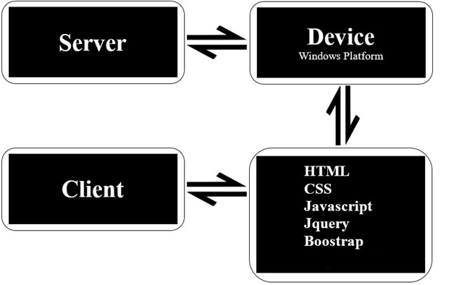

# Diagram of the website

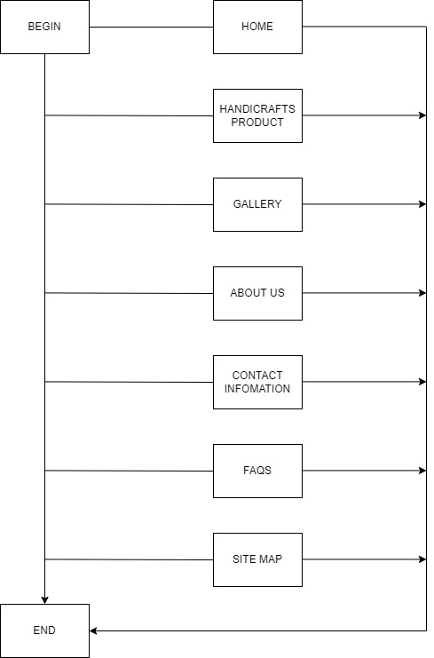



# TASK SHEET REVIEW 1

|  |  |  |  |  |  |  |  |
| --- | --- | --- | --- | --- | --- | --- | --- |
| **Project Ref. No.:**  **eP/Advertisement Portal Management**  **System/01** | | **Project Title:** | **Activity Plan Prepared By:** | **Date of Preparation of Activity Plan:** | | | |
| **Sr.**  **No.** | **Task** | **Actual**  **Start Date** | **Actual Days** | **Team**  **Mate Names** | **Status** |
| 1 | Problem Statement | Handicrafts | Phuc | 12-June-22 | 2 | Han | Completed |
| 2 | Analysis of Gracious Graments requirements about the website | 12-June-22 | 2 | Man | Completed |
| 3 | The scope of the work (in brief) | 12-June-22 | 2 | Tien | Completed |
| 4 | Architecture and design of the system | 12-June-22 | 2 | Tien | Completed |
| 5 | Diagram of the website | 12-June-22 | 2 | Phuc | Completed |
| 6 | Task Sheet | 12-June-22 | 2 | Phuc | Completed |
| 7 | Check, support, summarizing documentation file |  |  | 12-June-22 | 3 | Phuc | Completed |

|  |  |
| --- | --- |
| **Date:** | |
| Signature of Instructor:  **Mr. Le Thanh Nhan** | Signature of Team Leader:  **Pham Thien Phuc** |

# SITE MAP

We build the sitemap as follows:

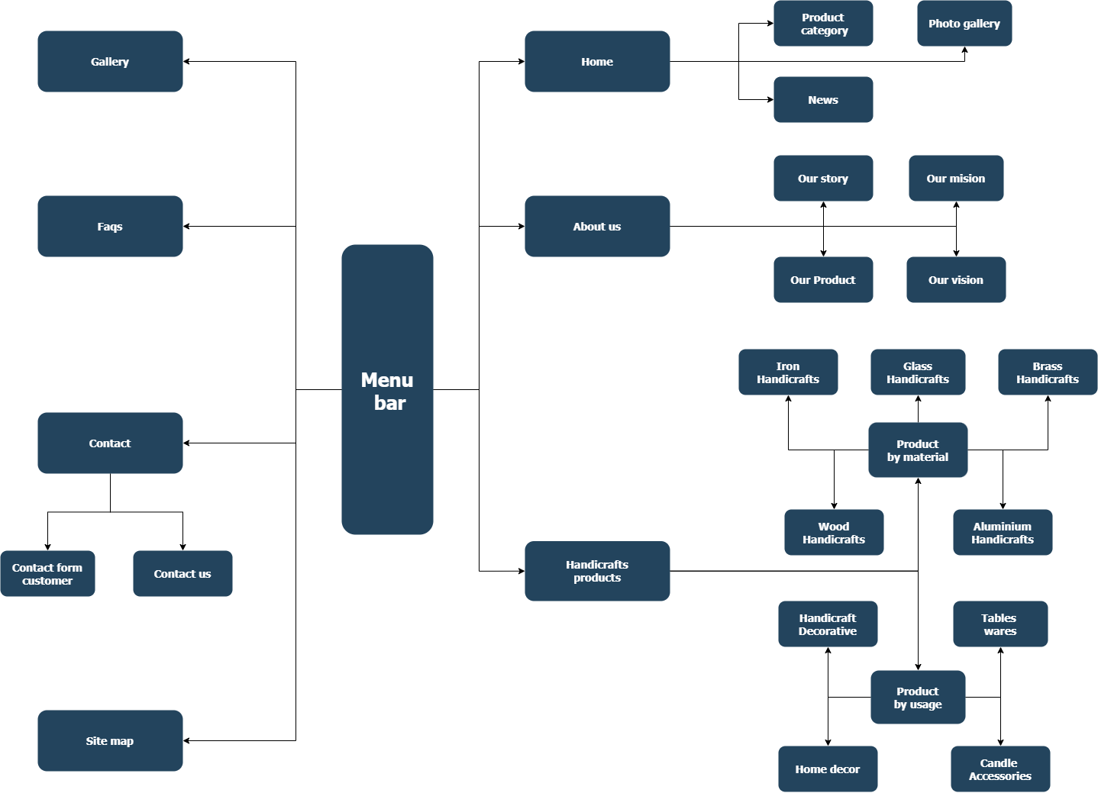

# MOCK OF THE WEBSITE

1. **Homepage**

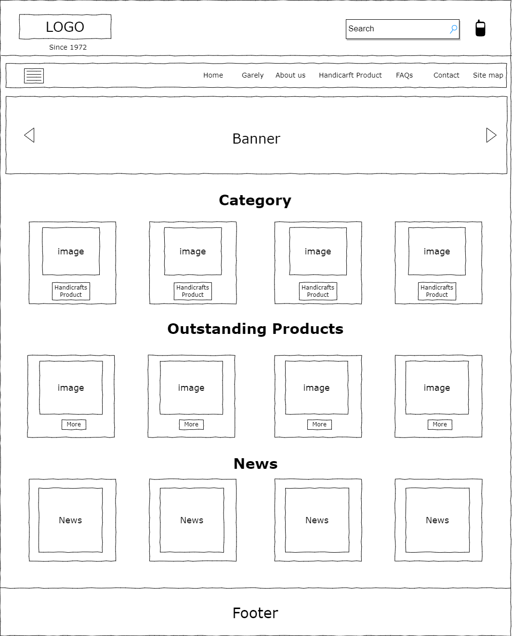

1. **Products**

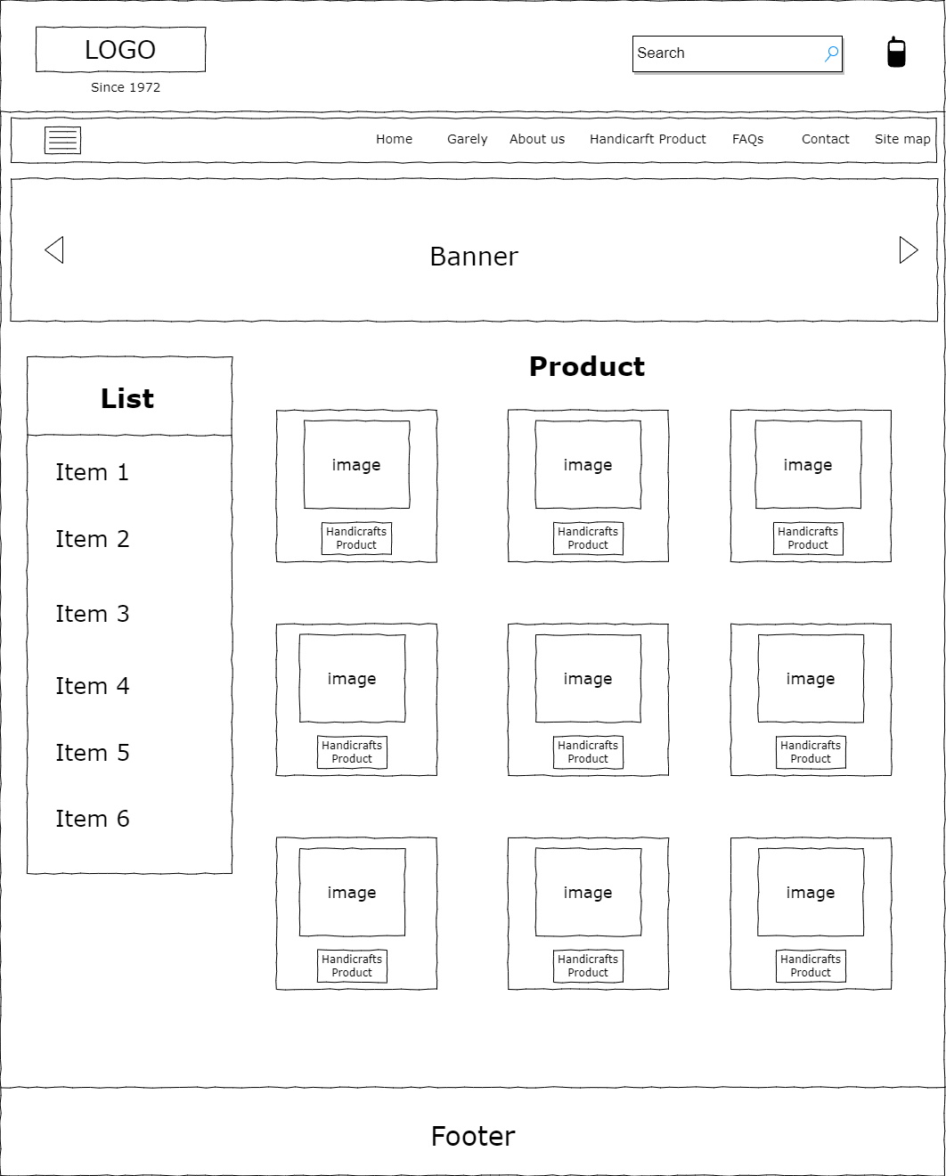

1. **About us**

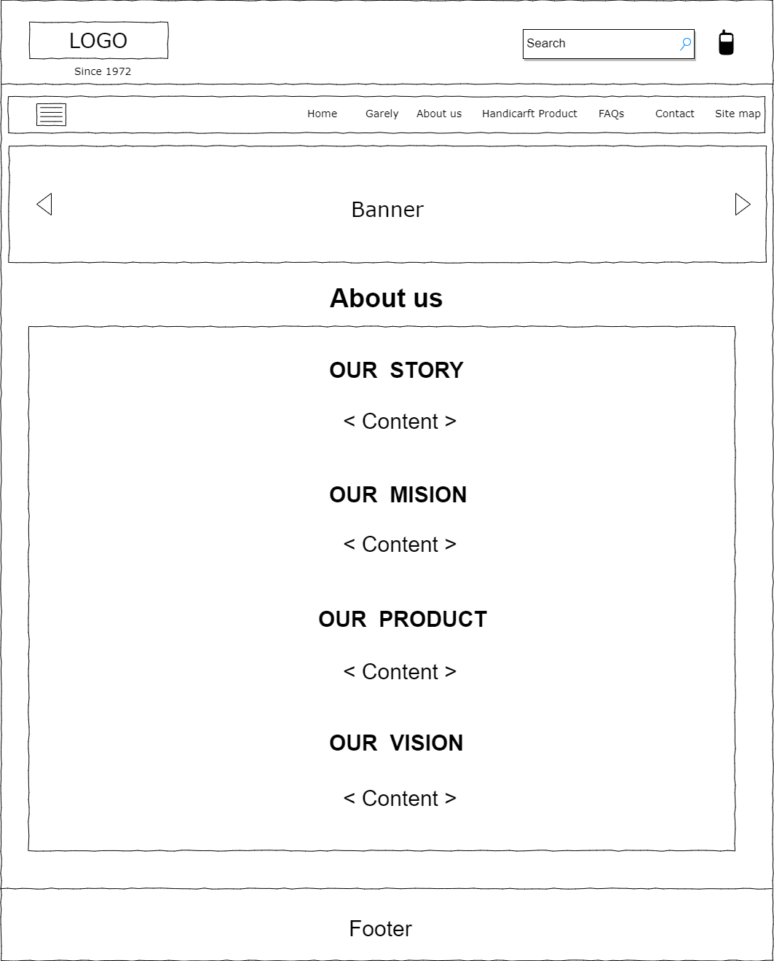

1. **Gallery**

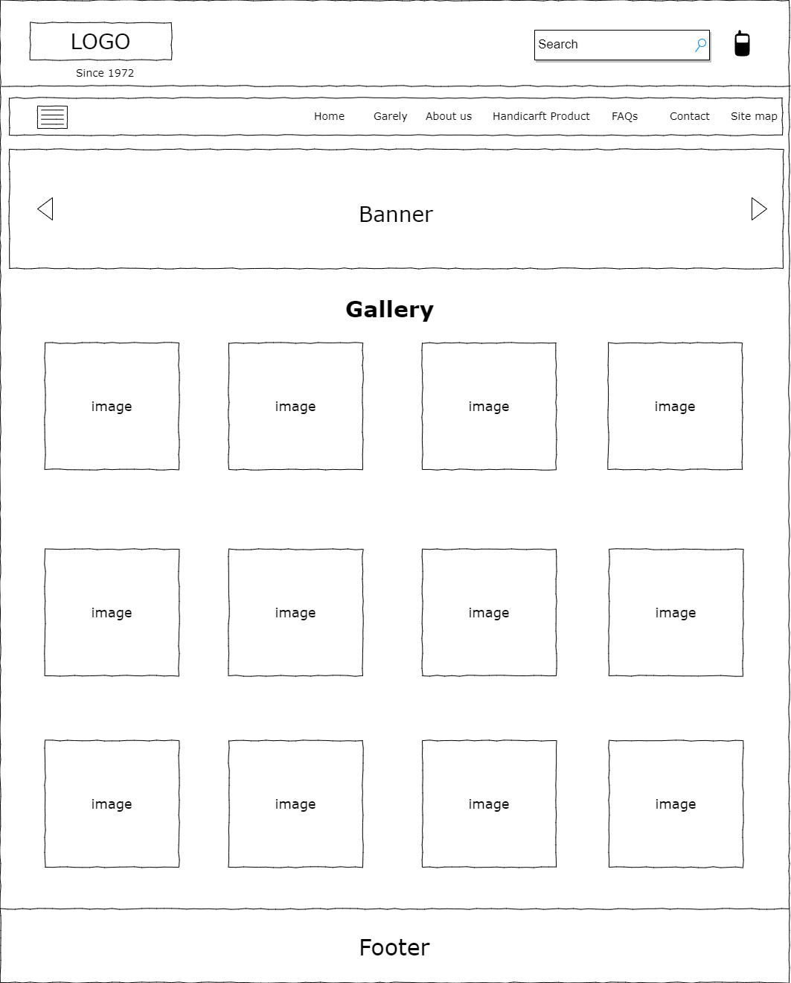

1. **Contact**

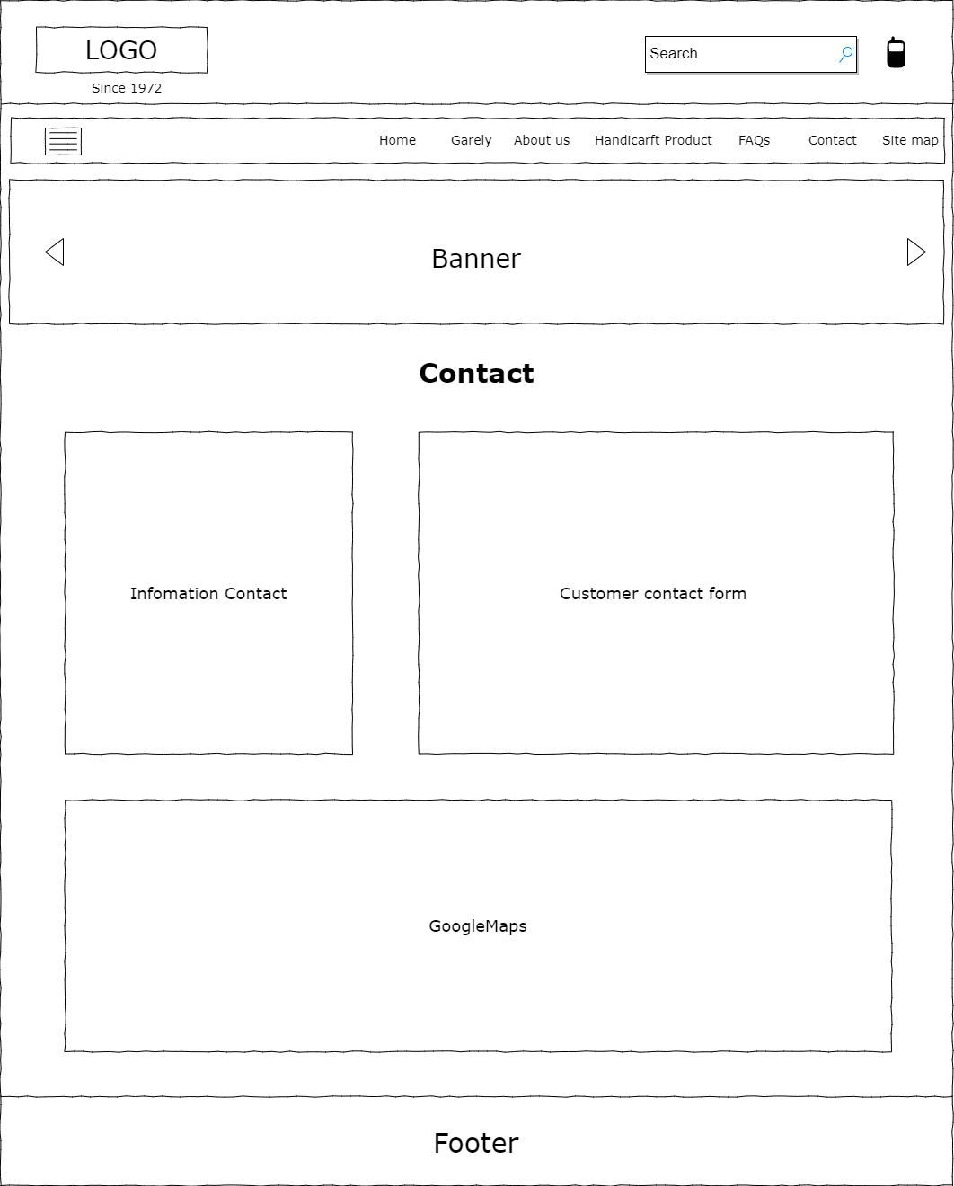

1. **FAQS**

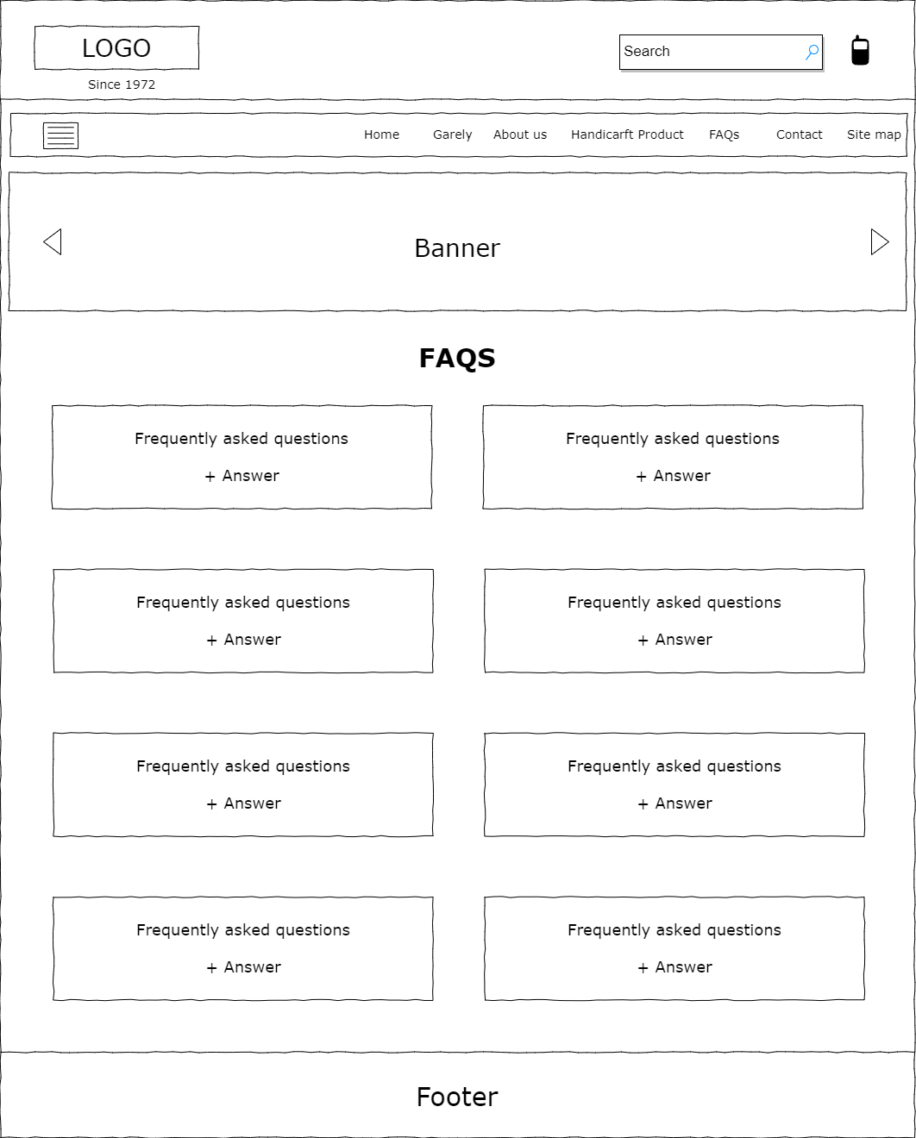

1. **Site map**

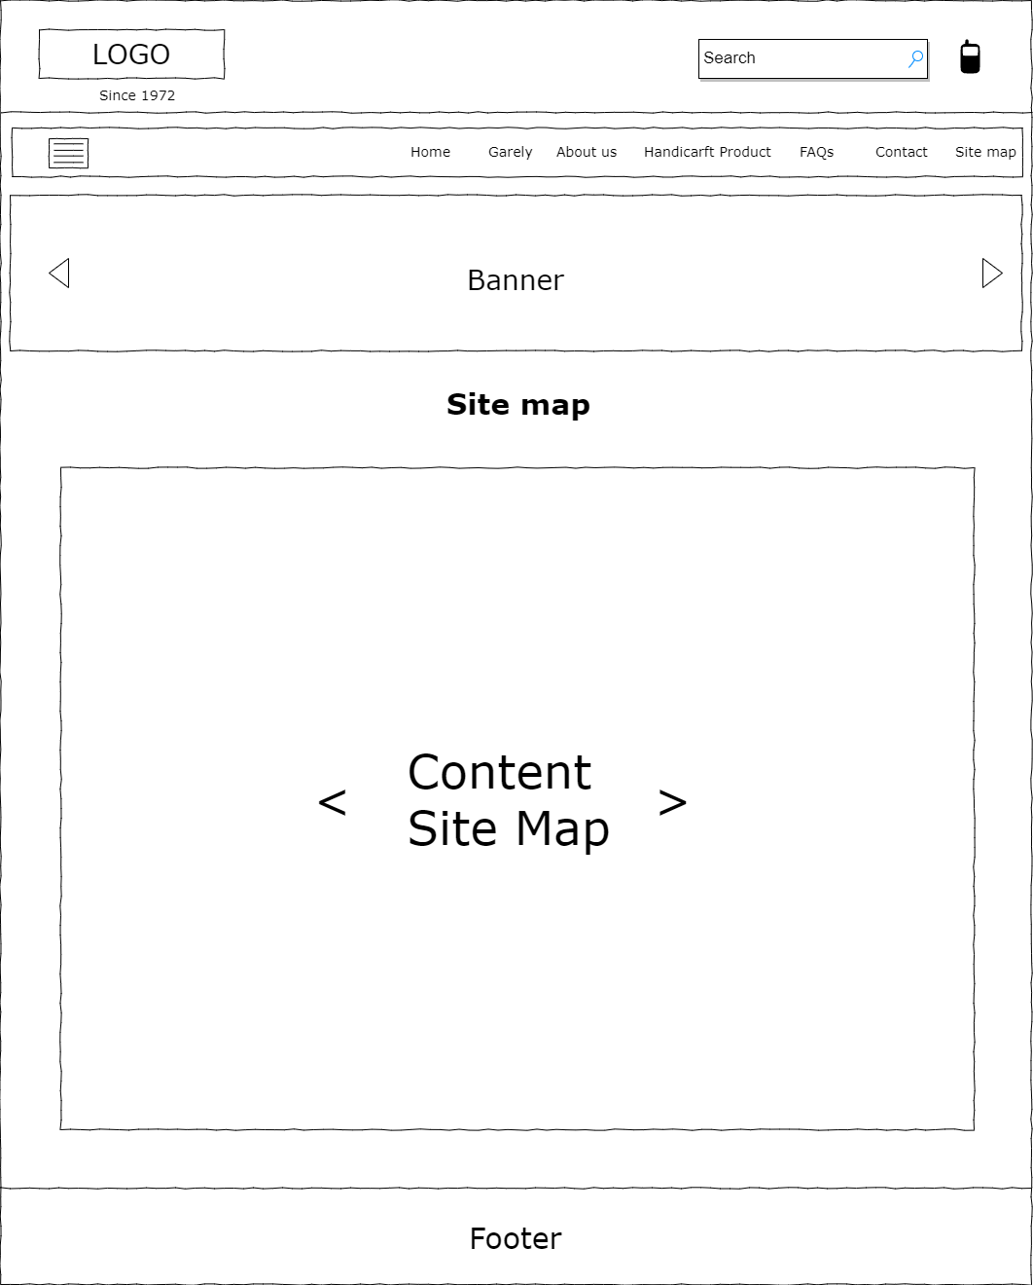

# TASK SHEET REVIEW 2

|  |  |  |  |  |  |  |  |
| --- | --- | --- | --- | --- | --- | --- | --- |
| **Project Ref. No.:**  **eP/Advertisement Portal Management**  **System/01** | | **Project Title:** | **Activity Plan Prepared By:** | **Date of Preparation of Activity Plan:** | | | |
| **Sr.**  **No.** | **Task** | **Actual**  **Start Date** | **Actual Days** | **Team**  **Mate Names** | **Status** |
| 1 | Site map | Handicrafts | Phuc | 16-June-22 | 4 | Phuc | Completed |
| 2 | Mock of the website Home page + About us page | 16-June-22 | 4 | Han | Completed |
| 3 | Mock of the website Products page + Garelly Page | 16-June-22 | 4 | Tien | Completed |
| 4 | Mock of the website Contact page + FAQS page + Site map page | 16-June-22 | 4 | Man | Completed |
| 6 | Task Sheet | 16-June-22 | 4 | Phuc | Completed |

|  |  |
| --- | --- |
| **Date:** | |
| Signature of Instructor:  **Mr. Le Thanh Nhan** | Signature of Team Leader:  **Pham Thien Phuc** |

# WEBSITE DESCRIPTION

1. **Home Page**

**Description:**

Home page displays has Header and footer following information:

* Header:
* Logo
* Contact phone
* Search
* Navagation bar
* Slideshow banner
* Footer:
* Infomation contact
* Logo
* Input email for guests to enter their email address to receive news

Home page displays following information:

* Product catalog,
* Product images,
* News of Venus Handicrafts.

**Screen shot:**

* Header:

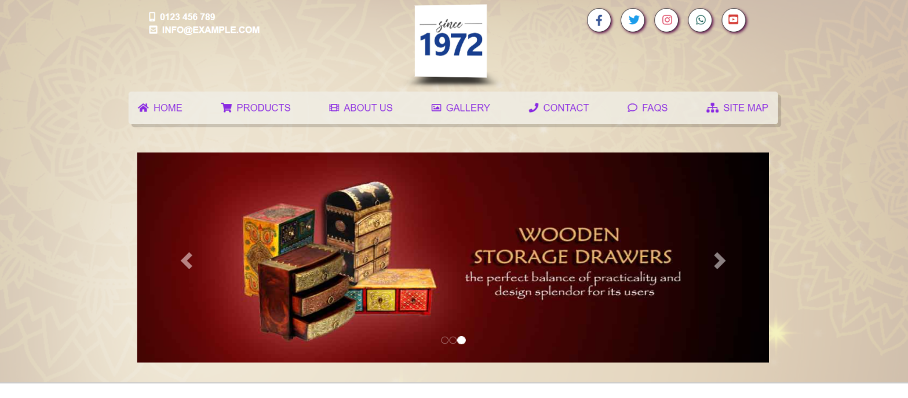

* Category

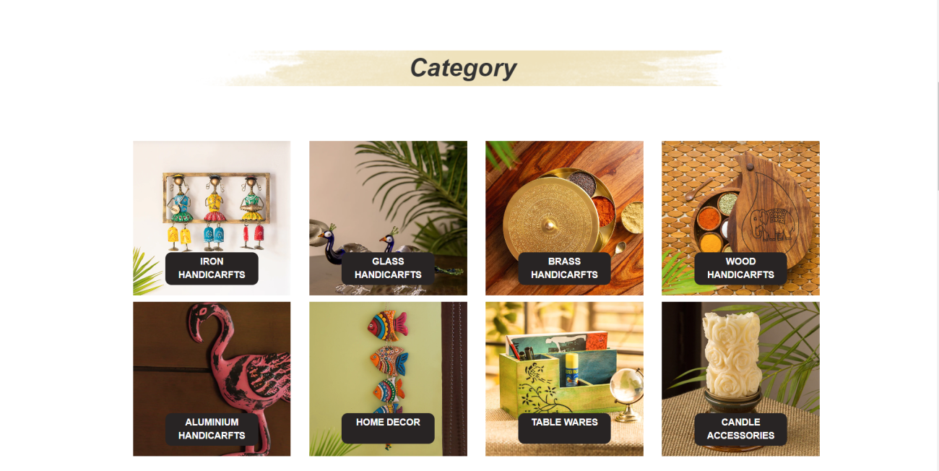

* Trending and new product

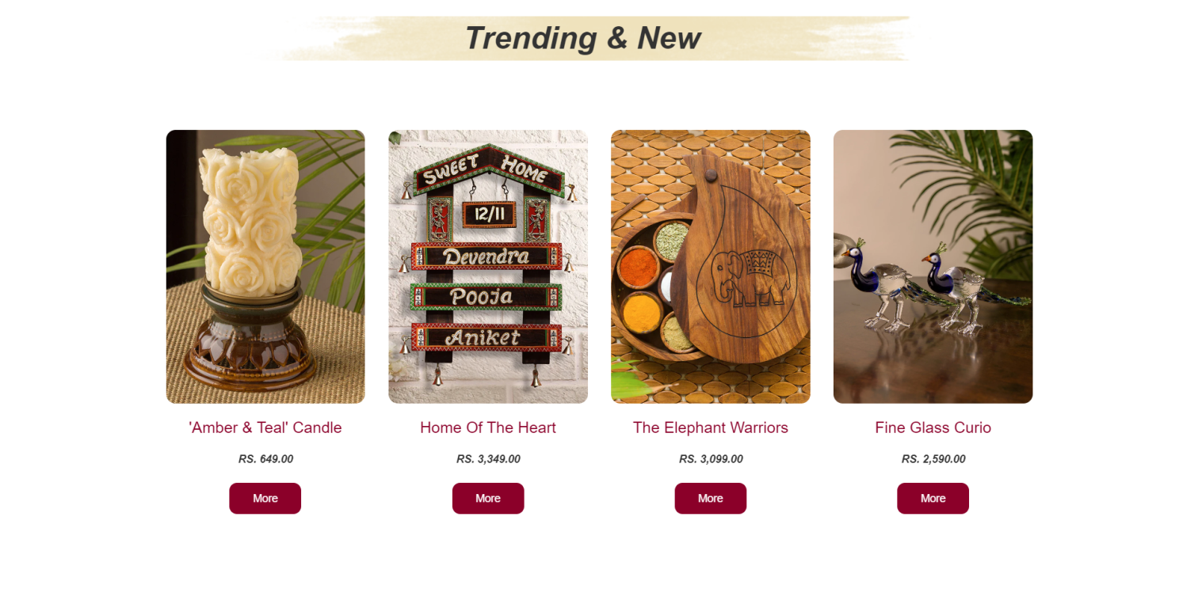

* News

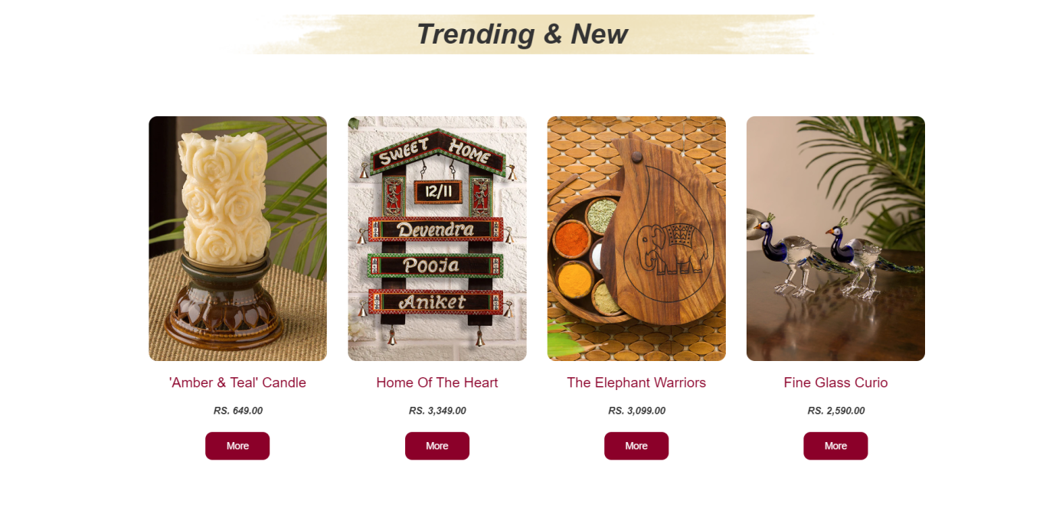

* Footer:

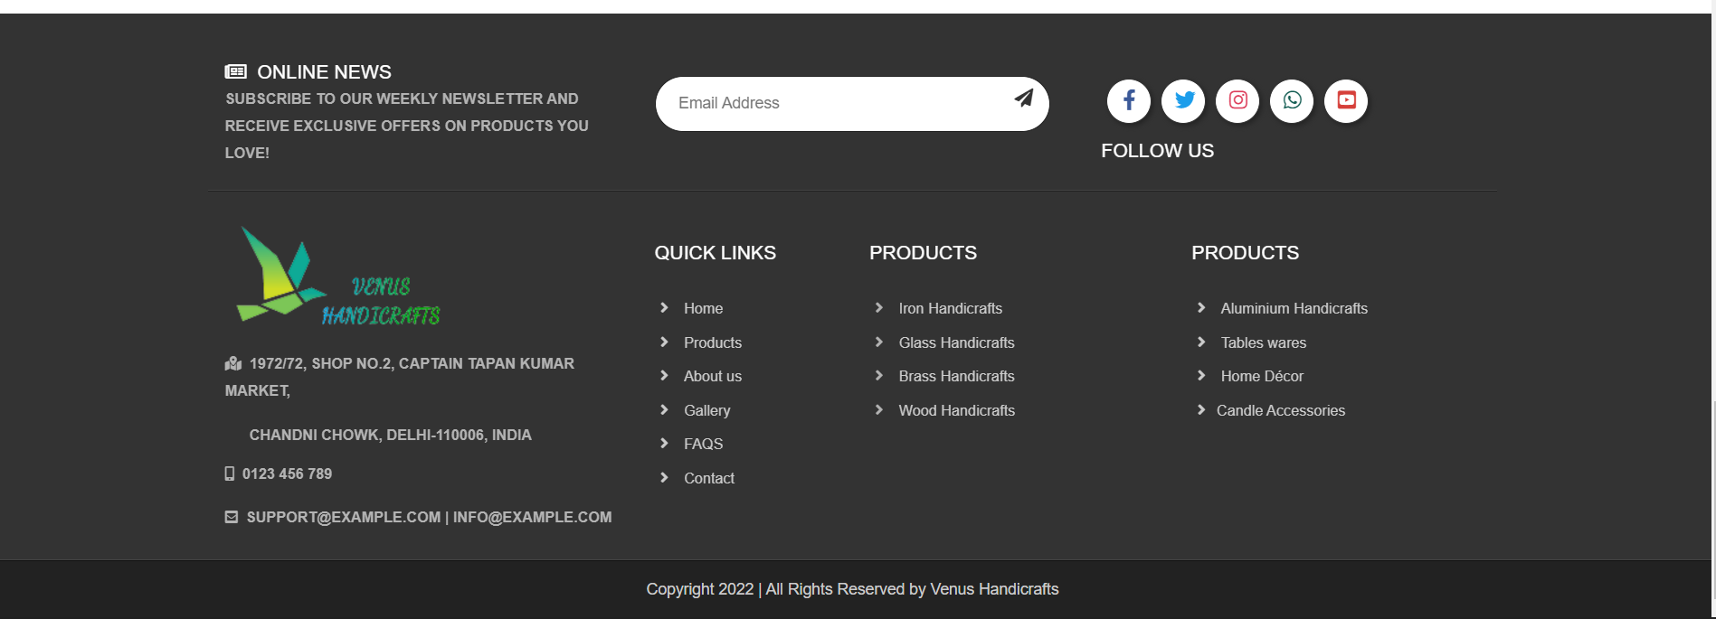

1. **Product**

**Description**:

Product page also has Header and footer that works like the Home page and other pages. It displays the following information:

* Show all products of Venus Handicraft.
* Customers can choose the products they want to see in the category with to the check box list box:
* Product by material
* Wood handicraft
* Iron handicraft
* Glass handicraft
* Brass handicraft
* Aluminum handicraft
* Product by usage
* Handicraft decorative
* Home décor
* Table wares
* Candle Accessories

**Screen shot:**

* Header:



* Sidlebar

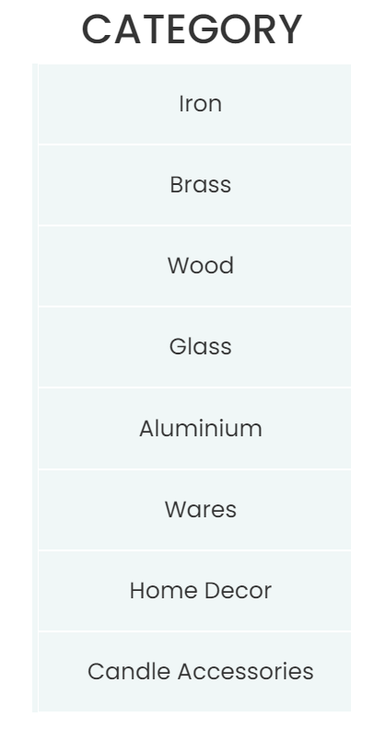

* Product

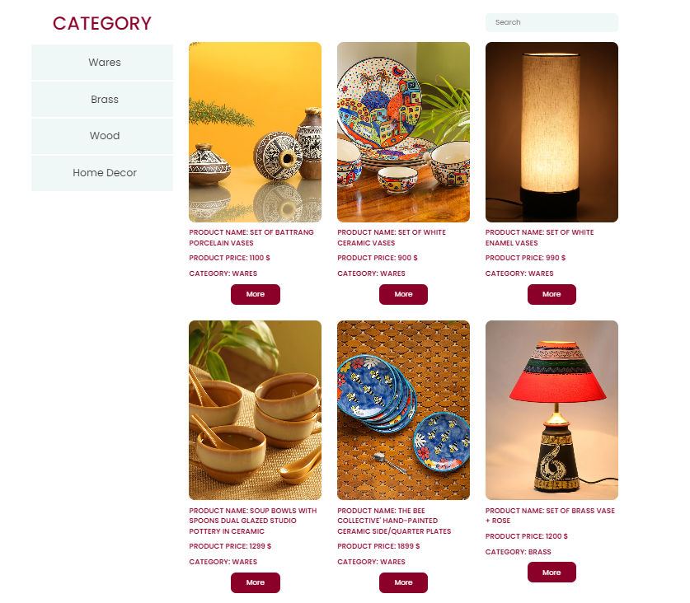

* Footer:



1. **Gallery**

**Description:**

Garellypage also has Header and footer that works like the Home page and other pages. This is a page that showing a wonderful collection of images of Venus Handicrafts products.

**Screenshot:**

* Header:

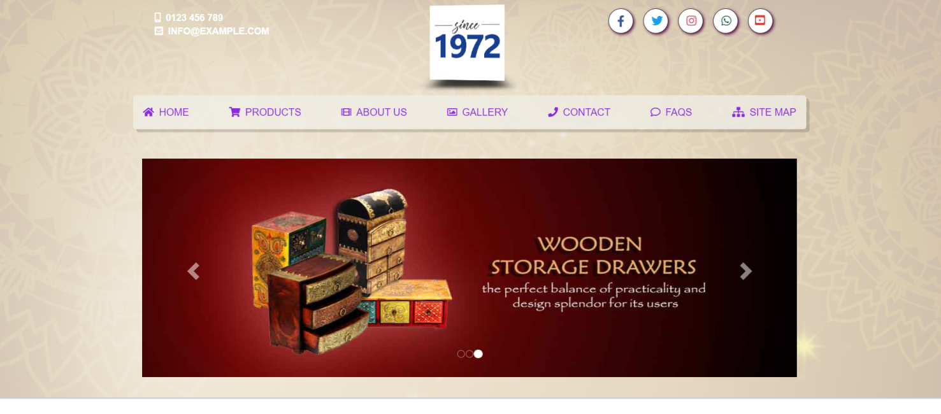

* Gallery

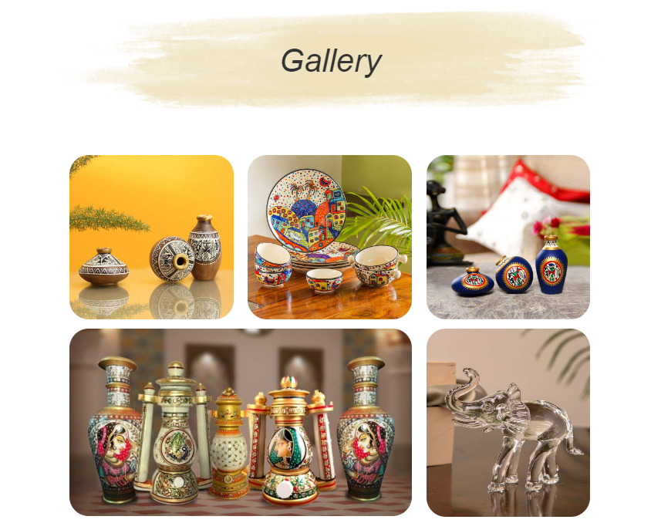

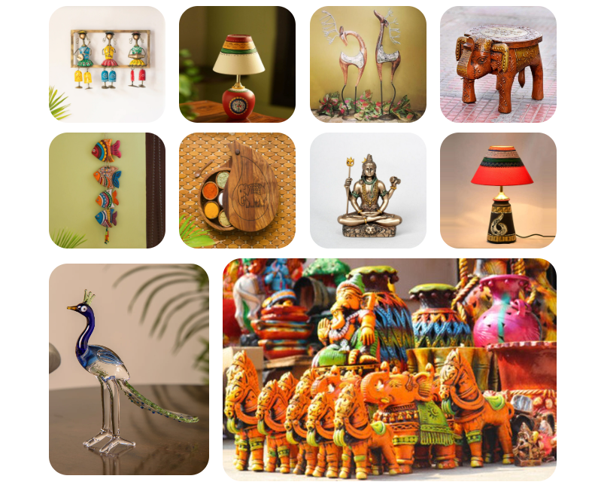

* Footer:

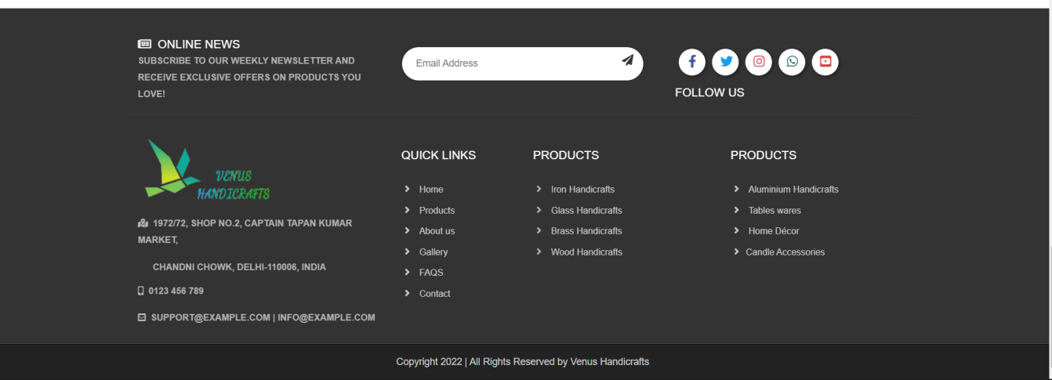

1. **About us**

**Description:**

About uspage also has Header and footer that works like the Home page and other pages. It displays the following information:

* Introduce to customers about the story of formation and development of Venus handicrafts.
* Introduce the quality of products to customers.
* Presentting the mission that the company wants to bring.
* Our vision of future growth.

**Screen shot:**

* Header:

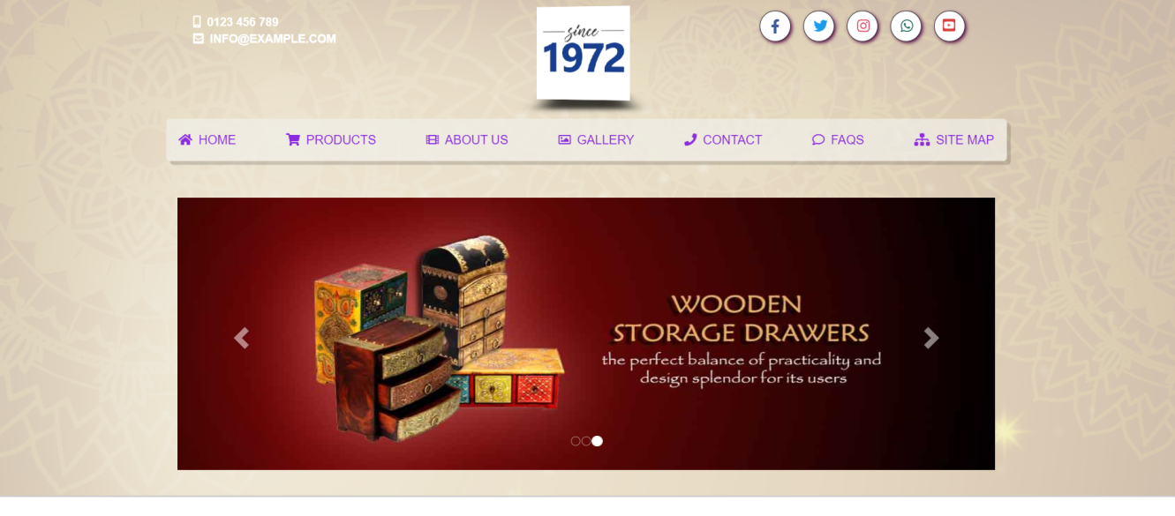

* Section

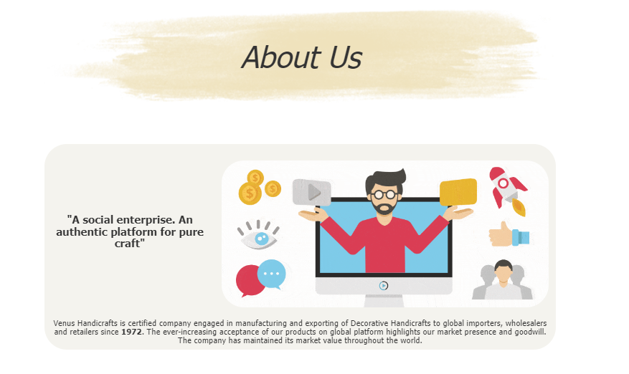

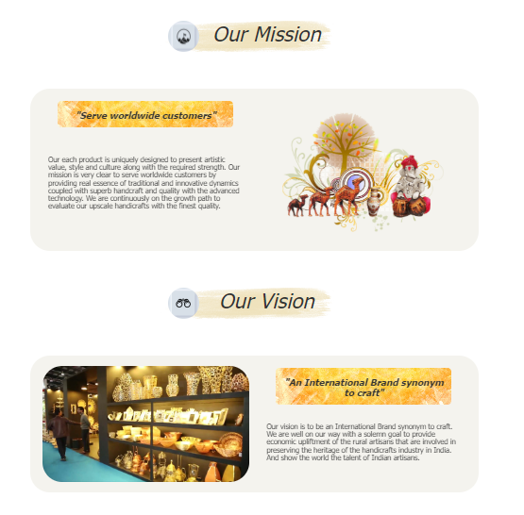

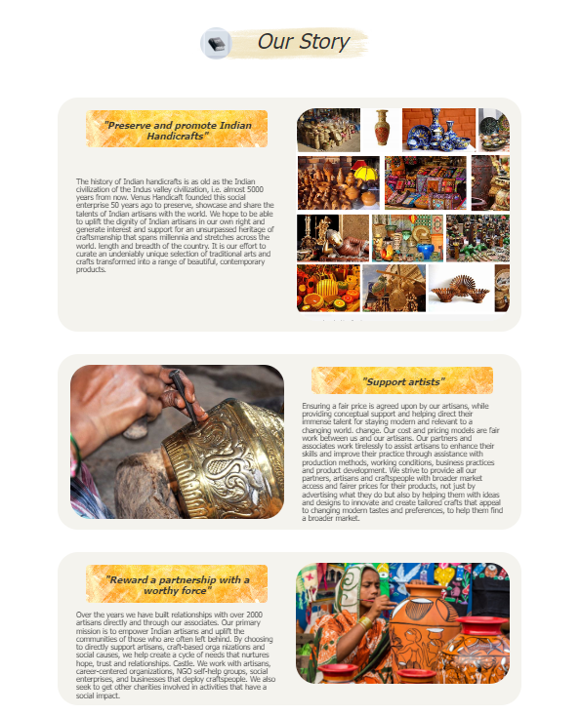

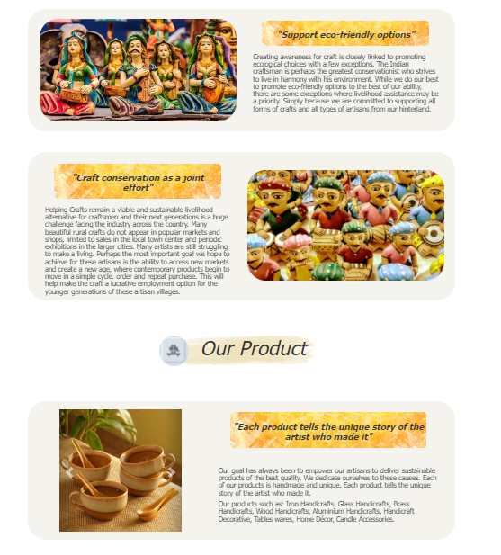

* Footer:



1. **Contact**

**Description:**

Contact page also has Header and footer that works like the Home page and other pages. It displays the following information:

* ContacThe page will display the company's contact information such as phone number, email, address.
* Share the location of the company's headquarters via a map on Google map.
* Customers can register contact information with the company.

**Screen shot:**

* Header:

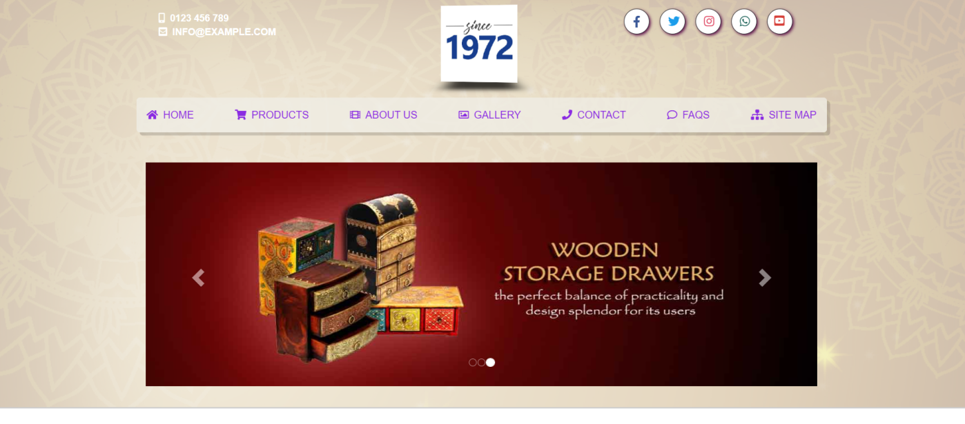

* Contact us:

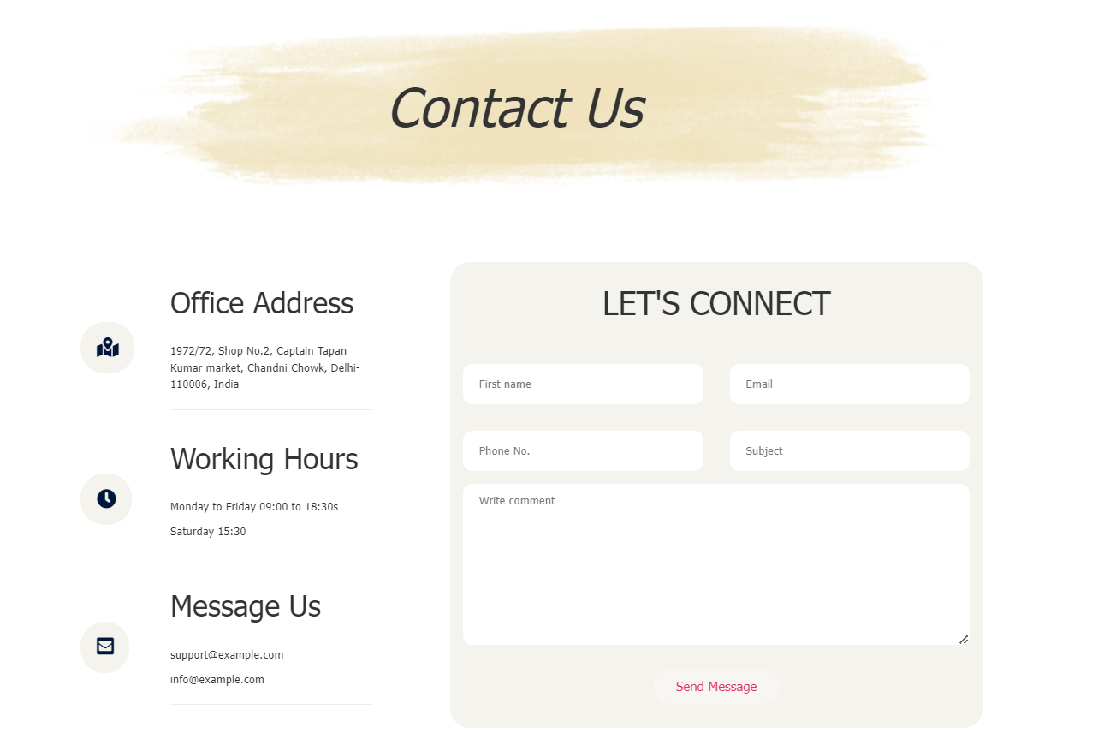

* Google maps:

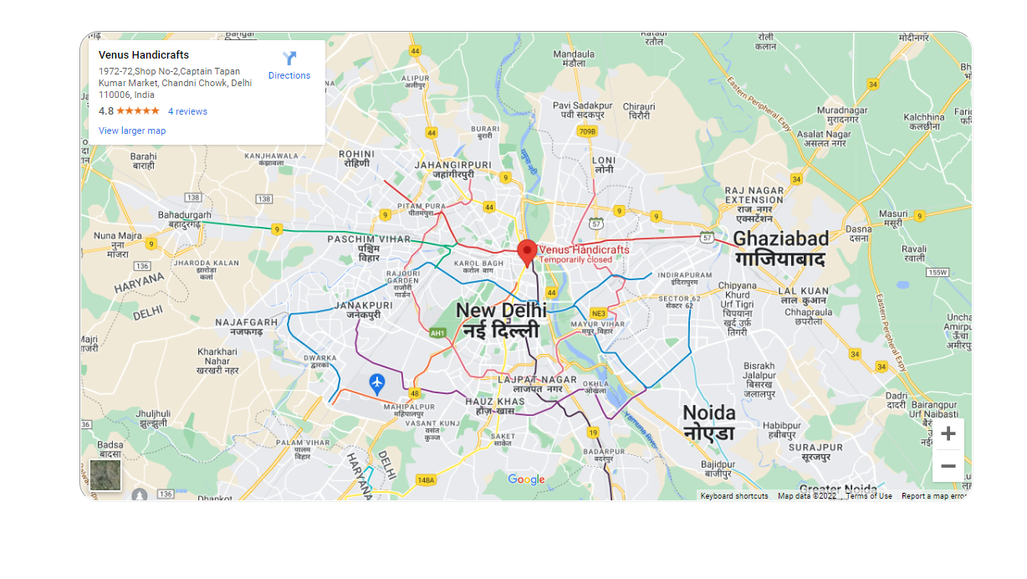

* Footer:

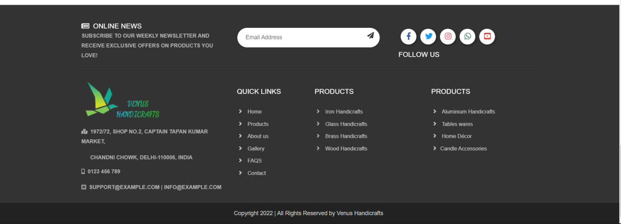

1. **FAQS**

**Description:**

FAQS page also has Header and footer that works like the Home page and other pages. This is a page that displays a list of frequently asked questions, it provides answers to each of the frequently asked questions that are displayed when the viewer clicks on that question.

**Screenshot:**

* Header:



* FAQs:

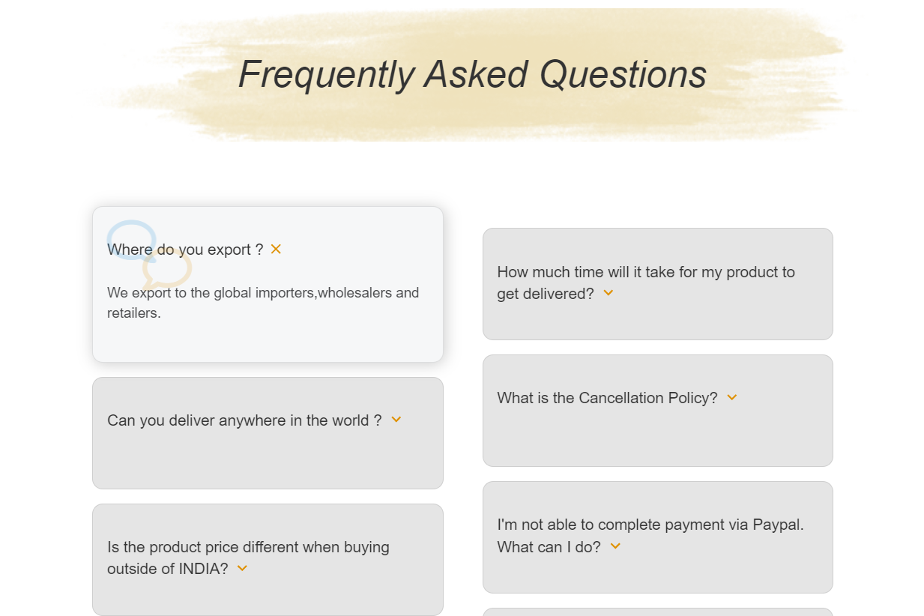

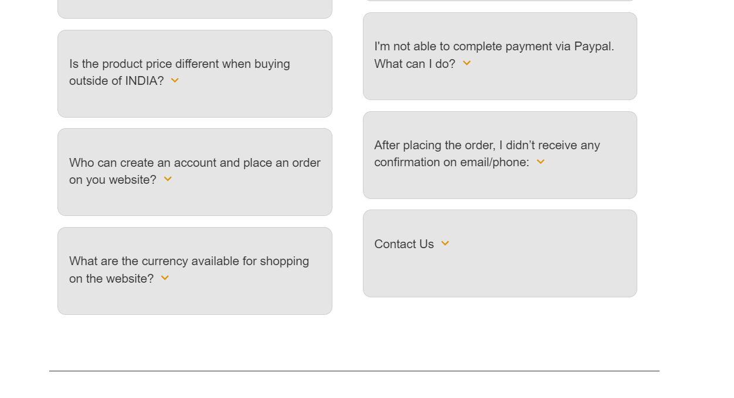

* Footer:

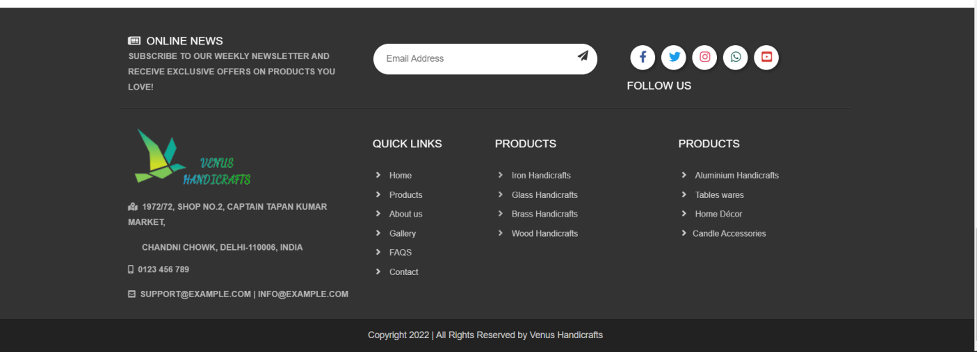

1. **Site map**

**Description:**

Clicking on the button sitemap on the menubar will link to the site section displayed under the footer. There will be links to the website's pages

**Screenshot:**



# WEBSITE REPONSIVE

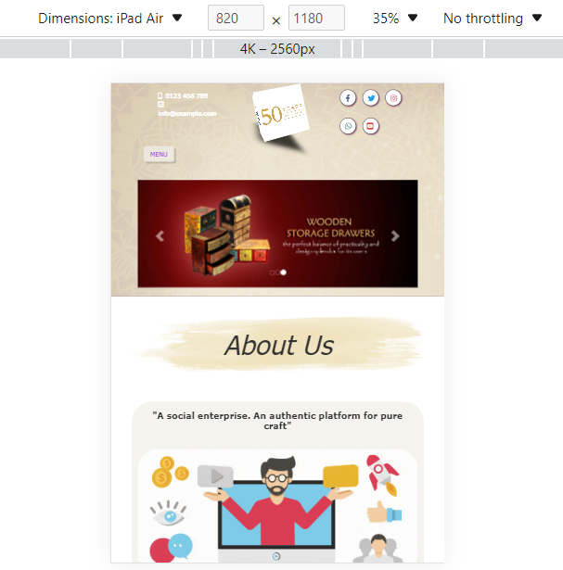

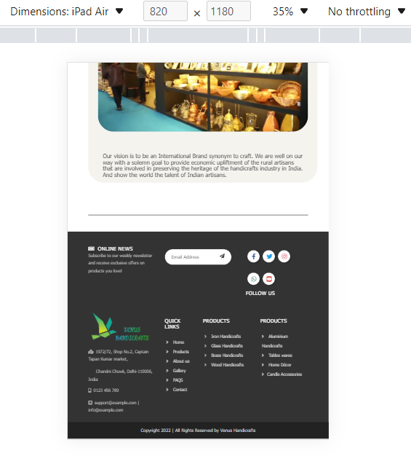

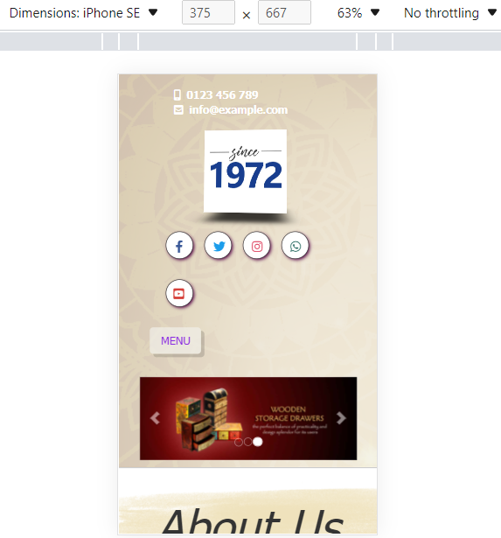

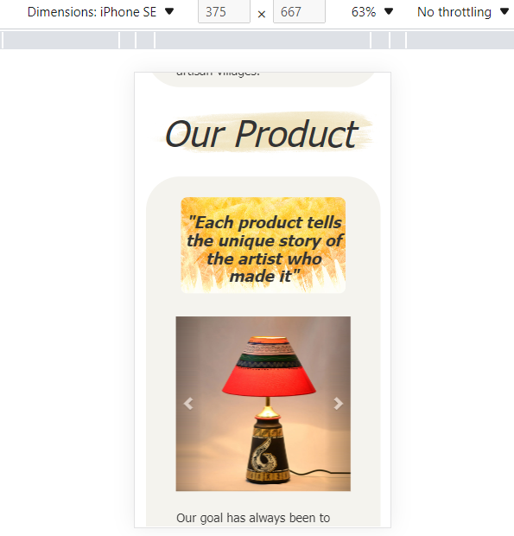

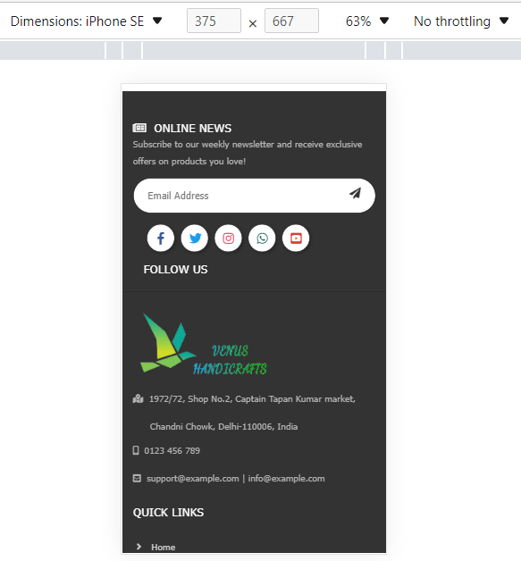

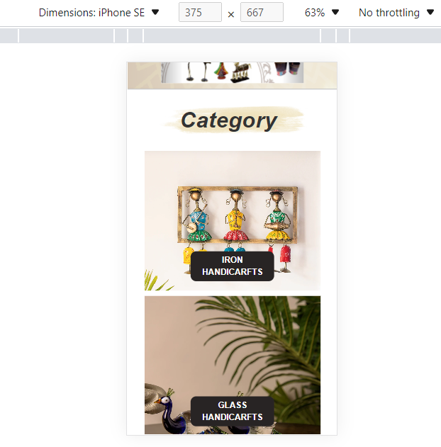

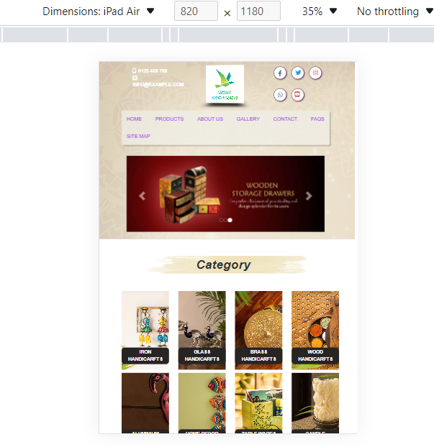

# TASK SHEET REVIEW 3

|  |  |  |  |  |  |  |  |
| --- | --- | --- | --- | --- | --- | --- | --- |
| **Project Ref. No.:**  **eP/Advertisement Portal Management**  **System/01** | | **Project Title:** | **Activity Plan Prepared By:** | **Date of Preparation of Activity Plan:** | | | |
| **Sr.**  **No.** | **Task** | **Actual**  **Start Date** | **Actual Days** | **Team**  **Mate Names** | **Status** |
| 1 | Home page (Write header, footer, content website) | Handicrafts | Phuc | 21-June-22 | 5 | Phuc + Man | Completed |
| 2 | Home page (Write website interface, content) | 21-June-22 | 5 | Han + Tien | Completed |
| 3 | Products page (Write content website) | 27-June-22 | 5 | Phuc + Man | Completed |
| 4 | Products page (Write interface, content website) | 27-June-22 | 5 | Han + Tien | Completed |
| 5 | Gallery page | 2-July-22 | 4 | Han + Tien | Completed |
| 6 | About us page | 2-July-22 | 4 | Phuc + Tien | Completed |
| 7 | Contact page | 7-July-22 | 3 | Han | Completed |
| 8 | FAQS page | 7-July-22 | 3 | Man | Completed |
| 9 | Site map page | 7-July-22 | 3 | Phuc | Completed |
| 10 | Integration, fix error | 11-July-22 | 5 | Phuc + Man Han + Tien | Completed |

|  |  |
| --- | --- |
| **Date:** | |
| Signature of Instructor:  **Mr. Le Thanh Nhan** | Signature of Team Leader:  **Pham Thien Phuc** |